Sqoop ingestion

Started by copying the file inside mysql docker container.



Second opened sql-container and got inside root.

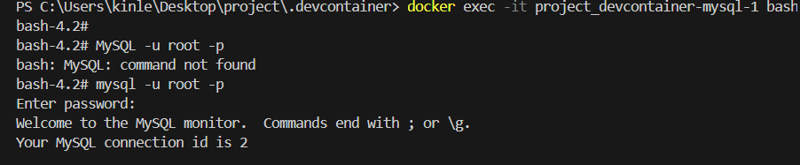

Created database city_temperature.



Then created table city_temperature.

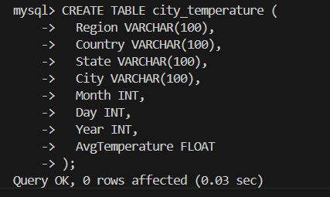

Loaded the from the file to the table inside city_temperature table.

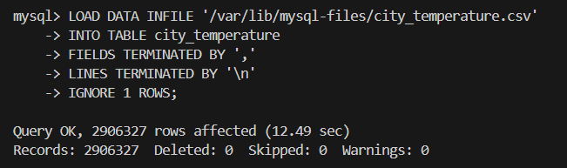

Viewed the data to verify whether its been added or not.

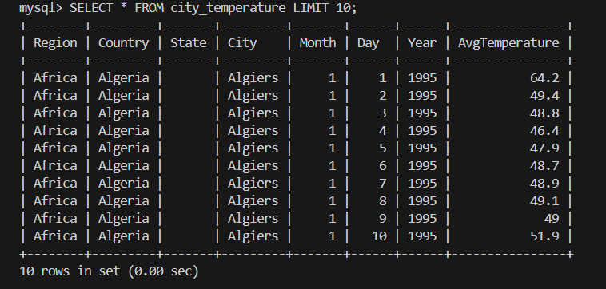

Made connection to docker network



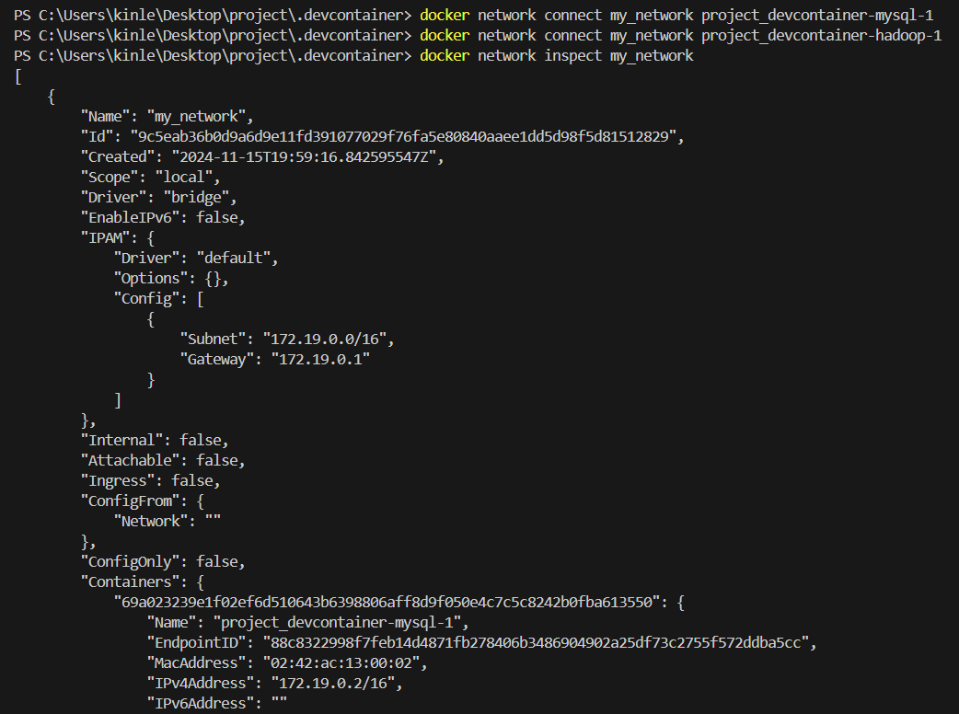

Used sqoop command to import the city_temperature file from sql to target directory inside hdfs

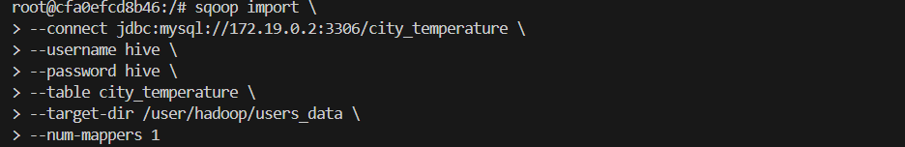

Verified hdfs to and to see saved city_temperature file



